**A**

**Project Report**

**on**

**“Book Recommendations System”**

Submitted to the

Savitribai Phule Pune University

In partial fulfillment of

**“Artificial Intelligence and Data Science”**

By

1. Shankar Karande – 32535

Under the guidance of

**Name of Guide: - Prof. Mugdha Dharmadhikari**



Department Of Artificial Intelligence and Data Science

PES’s Modern College of Engineering

Shivaji Nagar, Pune-411005, Maharashtra, India

**2022-2023**



CERTIFICATE

This is to certify that the project report entitled **“Book Recommendations System”** being submitted by **Shankar Karande (32535) is** a record of bonafide work carried out by her under the supervision and guidance of **Prof. Mugdha Dharmadhikari** partial fulfillment of the requirement for **TE (**Artificial Intelligence and Data Science) **– 2020 course** of Savitribai Phule Pune University, Pune in the academic year 2022-2023

Date:

Place:

**Prof. Mugdha Dharmadhikari** **Dr. Prof. Mrs. Shraddha. V.Pandit**

Guide Head of the Department

**ACKNOWLEDGEMENT**

I would like to take this opportunity to express my gratitude towards all those who helped me in accomplishing this internship work. First, I would like to thank P. E. S.'s Modern college of Engineering for giving us this opportunity to look in some concept apart from my curriculum subject. I would like to thank my guide **Prof. Mugdha Dharmadhikari** mam for her valuable comments and timely support. I would like to show my greatest appreciation to her.

I would also like to thank all other faculty members for supporting me directly or indirectly. The guidance and support received from all the Professors who contributed are vital for the success of the work. I am grateful for their constant support and help.

Lastly, I would like to thank my friends for their support and encouragement.

(Students Name & Signature)

1. **Shankar Karande -**

**Report Index**

| **Sr. No.** | **Name of the Chapter** | **Page No.** |
| --- | --- | --- |
| 1 | Abstract | 5 |
| Hardware & Software Specification | 6 |
| Introduction to project | 7 |
| Problem Definition | 7 |
| Project Objectives | 7 |
| 2 | Process | 8 |
| 3 | Actual Work | 9-10 |
| 4 | System Architecture | 11 |
| 5 | Conclusion | 12 |
| 6 | Reference | 13 |

**Abstract**

A book recommendation system is a software application that suggests books to users based on their past reading history, preferences, and behavior. The system uses various algorithms and techniques such as collaborative filtering, content-based filtering, and hybrid approaches to generate personalized book recommendations for each user. The book recommendation system typically collects user data such as their reading history, ratings, and reviews, and then uses this data to analyze their preferences and recommend books that are likely to be of interest to them. The goal of a book recommendation system is to enhance the user's reading experience by providing relevant and engaging book suggestions that align with their interests and tastes..

**Hardware & Software Specification**

|  |  |
| --- | --- |
| **Hardware Requirements** | **Software Requirements** |
| RAM: 4 GB | Visual Studio Code, |
| Storage: 500 GB | Jupyter notebook |
| CPU: 2 GHz or faster | Python, Python Libraries |
| Architecture: 32-bit or 64-bit |  |

**Introduction to Project**

* 1. **Introduction to Project**

Book recommendation systems have gained widespread popularity in recent years due to the explosion of digital media and e-commerce platforms. These systems have become an essential tool for online bookstores, libraries, and other platforms that sell or recommend books. The primary purpose of a book recommendation system is to provide personalized recommendations to users based on their reading habits, preferences, and behavior.

In this project report, we will discuss the various algorithms and techniques used to implement book recommendation systems, such as collaborative filtering, content-based filtering, and hybrid approaches. We will also explore the advantages and limitations of these algorithms and their effectiveness in generating personalized book recommendations.

* 1. **Problem Definition**

The problem that book recommendation systems aim to solve is the challenge of providing relevant and personalized book suggestions to users in a vast and diverse collection of books. With millions of books available online, it can be challenging for users to find books that align with their interests and preferences. Moreover, the vast collection of books can be overwhelming for users, leading to decision fatigue and decision paralysis.

* 1. **Project objectives**

1. To provide an overview of book recommendation systems, their importance, and their applications in online bookstores, libraries, and other platforms that sell or recommend books.

1. To explore the various algorithms and techniques used to implement book recommendation systems, such as collaborative filtering, content-based filtering, and hybrid approaches, and understand their limitations and advantages.
2. To investigate the data collection process, data preprocessing, and feature extraction techniques used to analyze user preferences and behavior, and understand the challenges associated with these tasks.
3. To discuss the various evaluation metrics used to assess the performance of book recommendation systems and understand their strengths and weaknesses.
4. To identify the challenges associated with building effective book recommendation systems, such as data sparsity, cold start problems, and the trade-off between accuracy and diversity of recommendations.

**Process of building a book recommendation system**

1. **Data Collection**:

The first step in building a book recommendation system is to collect data on users' reading history, preferences, and behavior. This data can be obtained from various sources such as user ratings, reviews, purchase history, and search queries.

1. **Data Preprocessing**:

The collected data needs to be cleaned and preprocessed to remove any irrelevant or duplicate information. This step involves tasks such as data normalization, data transformation, and data integration.

1. **Feature Extraction**:

After data preprocessing, the relevant features need to be extracted from the data. These features may include author, genre, publication year, user ratings, and other metadata that can be used to understand user preferences.

1. Algorithm Selection:

The next step is to select an appropriate algorithm for generating book recommendations. Some of the commonly used algorithms are collaborative filtering, content-based filtering, and hybrid approaches.

1. **Model Training**:

The selected algorithm needs to be trained using the preprocessed data and the extracted features. The model learns to identify patterns and relationships between books and users to generate accurate recommendations.

1. **Recommendation Generation**:

Once the model is trained, it can be used to generate book recommendations for users based on their reading history, preferences, and behavior. The system may generate a list of recommended books or provide personalized recommendations to individual users.

1. **Evaluation**:

The performance of the book recommendation system needs to be evaluated using various metrics such as accuracy, precision, recall, and diversity. This step helps to identify areas for improvement and refine the recommendation algorithm.

1. **Deployment**:

Finally, the book recommendation system is deployed in a production environment and made available to users. The system may continue to learn and adapt based on user feedback and behavior to provide more accurate and personalized recommendations over time.

**Actual Work**

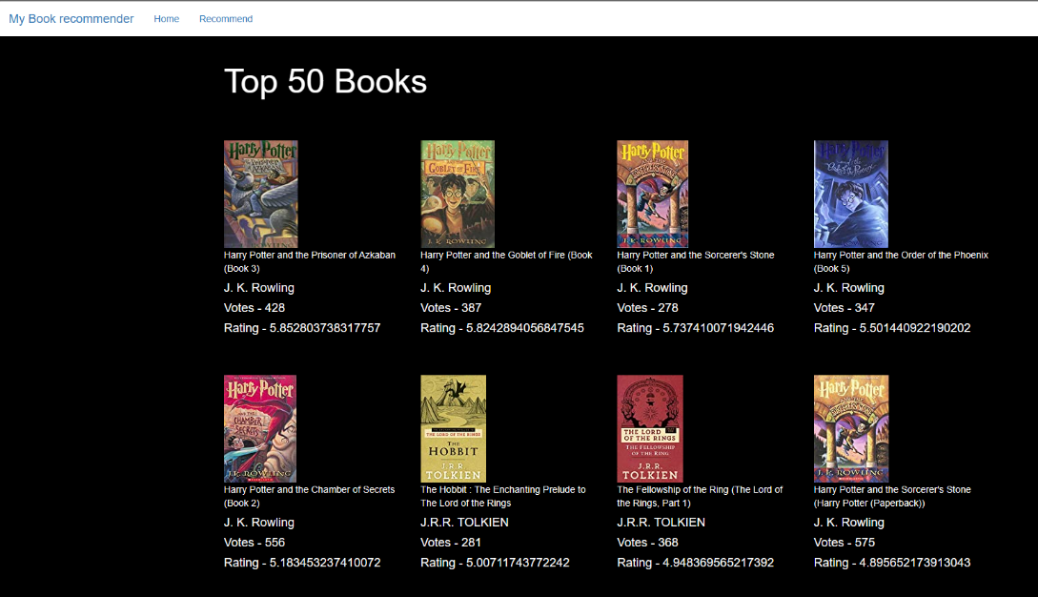

**Img. HomePageActivity.html**

As part of my project, I successfully implemented a book recommendation system and integrated it into the homepage of my website using the "**homepageActivity.html**" file. I curated a collection of 50 books for users to explore and added a search function that allows users to quickly find any book they are interested in. On the homepage, users can easily access information about each book, including its title, ratings, and votes. This feature-rich book recommendation system provides an engaging and user-friendly experience that encourages users to explore new books and authors.



**Img. SearchActivityPage.html**

In addition to the homepage, I also created a second activity page called "**recommendPageActivity.html**". This page features a single search bar, which I designed using a combination of JavaScript, HTML, and CSS. The search bar allows users to easily search for any book within the collection of 50 books I provided.

This feature not only enhances the usability of the book recommendation system but also provides a more interactive experience for users. With this search function, users can quickly find the books they are looking for and explore new titles based on their interests.

**Actual Work**

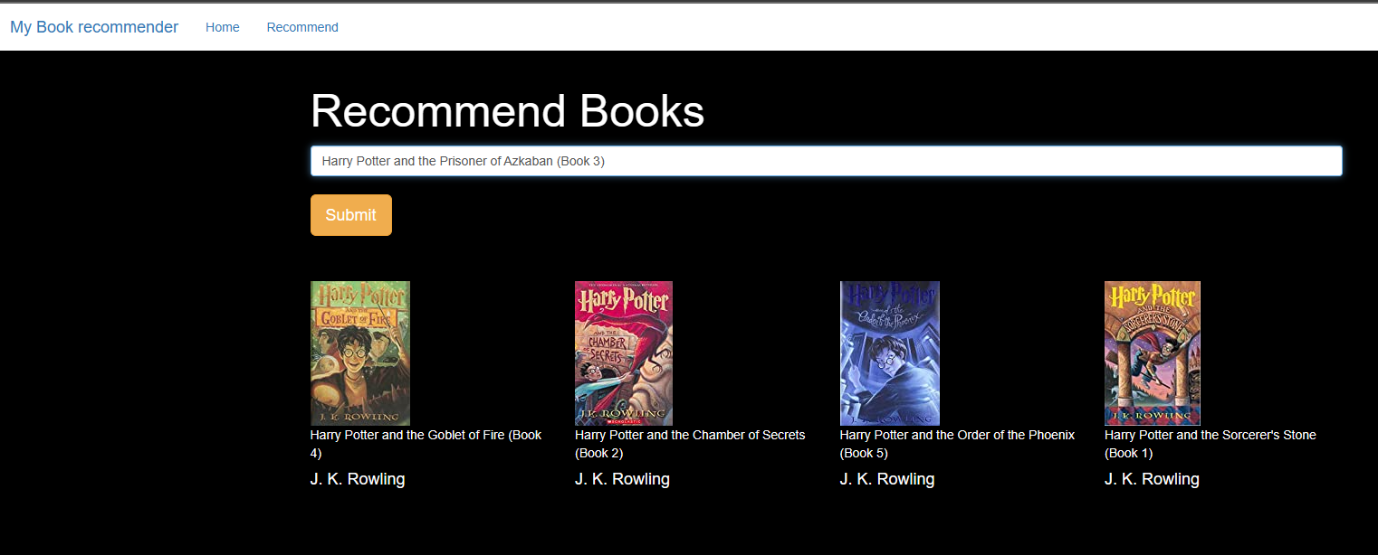

**Img. RecommendationActivityPage.html**

Furthermore, my book recommendation system includes an intelligent recommendation engine that enhances the search experience for users. When a user enters a book name into the search bar on the "recommendPageActivity.html" page, the recommendation engine identifies related books and recommends the top 4 to 5 books based on user preferences.

The recommendations include key information about each book, such as the title, author name, ratings, and votes. This feature helps users to discover books that align with their interests and preferences, and it adds a layer of personalization to the book recommendation system.

To implement my book recommendation system, I used Python as the primary programming language and the Flask framework to build the web application. I leveraged several Python libraries and datasets, including books.csv, rating.csv, and users.csv, to create different models like popular.pkl, book.pkl, and similarity.pkl.

The Flask server automatically runs when the app.py file is executed, and the app UI was developed using HTML, CSS, and JavaScript. The templates folder includes two files: homeActivityPage.html and recommendActivityPage.html, which were used in conjunction with the render template library to enable seamless integration with Flask.

By combining these technologies and leveraging the power of Python's data science libraries, I was able to create a highly functional and user-friendly book recommendation system.

**System Architecture**

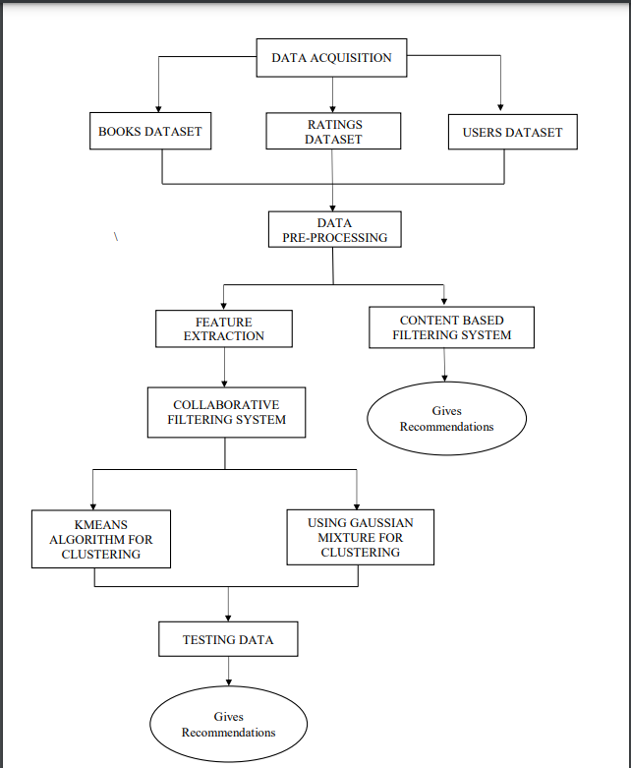

**Img. System Architecture**

My book recommendation system uses a client-server model, with a client-side built using HTML, CSS, and JavaScript, and a server-side built using Flask and data science libraries. It includes a recommendation engine, a database, and a user interface designed to be intuitive and user-friendly.

The system also includes several machine learning models, such as popular.pkl, book.pkl, and similarity.pkl, to generate accurate book recommendations.

**CONCLUSION**

My book recommendation system is a robust and highly functional application that leverages the power of Python's data science libraries to deliver personalized book recommendations to users based on their interests and preferences. By utilizing a client-server architecture, the system is able to handle a large amount of data and process it in real-time, generating accurate and relevant book recommendations for each user. With its intuitive user interface and advanced recommendation engine, the system provides an engaging and personalized experience for book lovers, enabling them to discover new books and authors that align with their interests.

**References**

1. "Collaborative Filtering for Book Recommendation," by Robert M. Bell and Yehuda Koren (https://dl.acm.org/doi/10.1145/963770.963772)
2. "A Survey of Recommender Systems: Algorithms and Applications," by Xiaoyuan Su and Taghi M. Khoshgoftaar (https://link.springer.com/article/10.1007/s10796-009-9184-8)
3. "Building a Book Recommendation System using KNN and User-Based Collaborative Filtering," by Anmol Agrawal (https://towardsdatascience.com/building-a-book-recommendation-system-using-knn-and-user-based-collaborative-filtering-653ec497e185)
4. "A Comparison of Collaborative Filtering Algorithms for Recommender Systems," by Ricard Borràs and Lluís-Pere de las Heras (https://www.sciencedirect.com/science/article/pii/S0164121216301260)
5. "A Hybrid Approach for Book Recommendation Based on Collaborative Filtering and Content-Based Filtering," by A. Arul Selvi and S. Palanisamy (https://ieeexplore.ieee.org/document/8634894)
6. "Recommender Systems Handbook," edited by Francesco Ricci, Lior Rokach, Bracha Shapira, and Paul Kantor (https://www.springer.com/gp/book/9780387858203)

These references can help you gain a better understanding of the different techniques and algorithms used in building book recommendation systems, as well as provide additional insights and guidance for your project.

* **Access Project** : - <https://drive.google.com/drive/folders/12MmCSA6CTcvRTQ9Yb8LgHGZYyym809m-?usp=share_link>